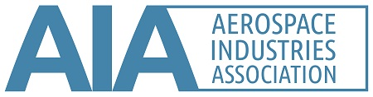
Application for Non-Member Participation on AIA Standards Development
Membership on an AIA American National Standard Working Group (ANSWG) is open to directly and materially affected parties, in accordance with SGC-1, Appendix A, Section 2.2. Non-members may apply for membership on an AIA ANSWG, which may include a reasonable participation fee. A waiver of the participation fee may be requested with justification. At this time, there is no participation fee.

Completed applications and/or questions may be sent to nas.standards@aia-aerospace.org or the AIA team member managing the ANSWG of interest.

Name:
Title:
Organization:
Contact information:
(mailing address, email address, phone number)
Project of interest:
Name of ANSWG:
Interest category:
Describe how you will be affected by the proposed American National Standard:

For questions about the development of AIA/NAS American National Standards, please refer to SGC-1, Development Procedures for National Aerospace Standards, and ANSI’s Essential Requirements.

